|  |  |
| --- | --- |
| Course Name | ITD 2313 – Script Programming |
| Instructor | M. Schnell |
| Student Name | Mysam Ata |
| Due date | June 11th |
| Grade | Put grade earned here |
| Grading Comments | Put instructor comments here |

Scripting Projects Week 1

1. 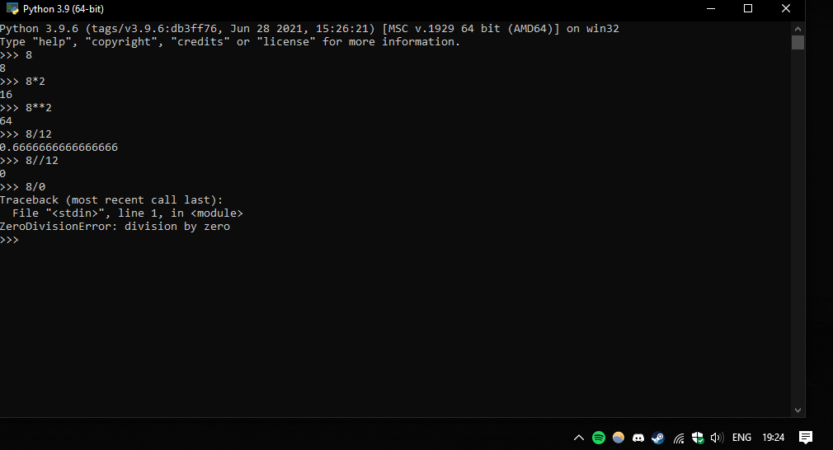
2. 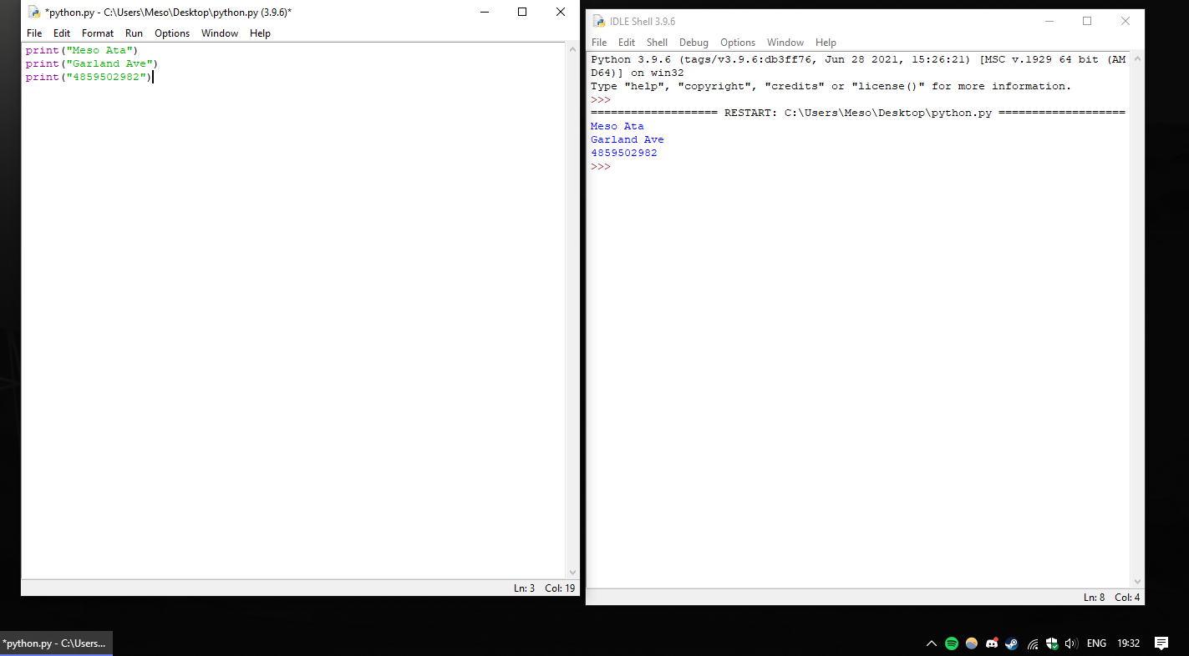
3. 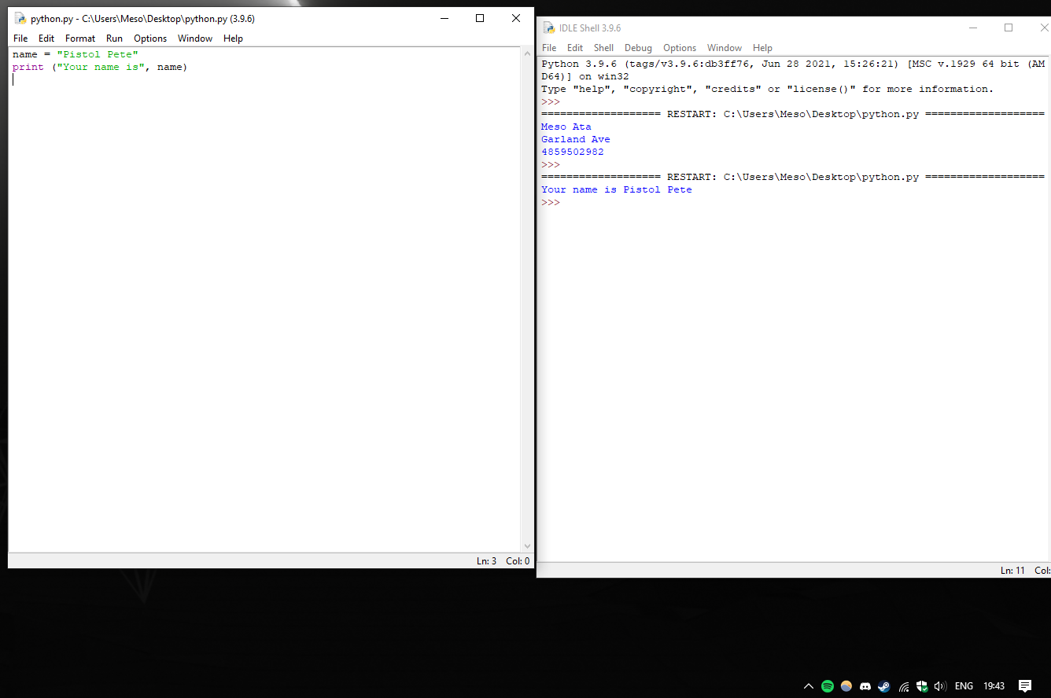
4. 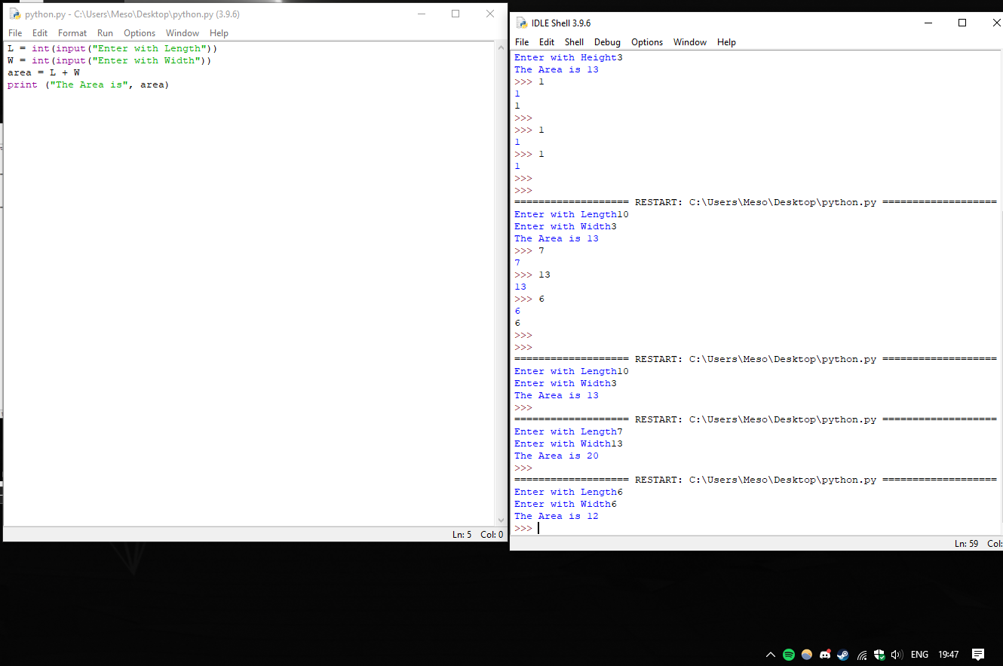
5. 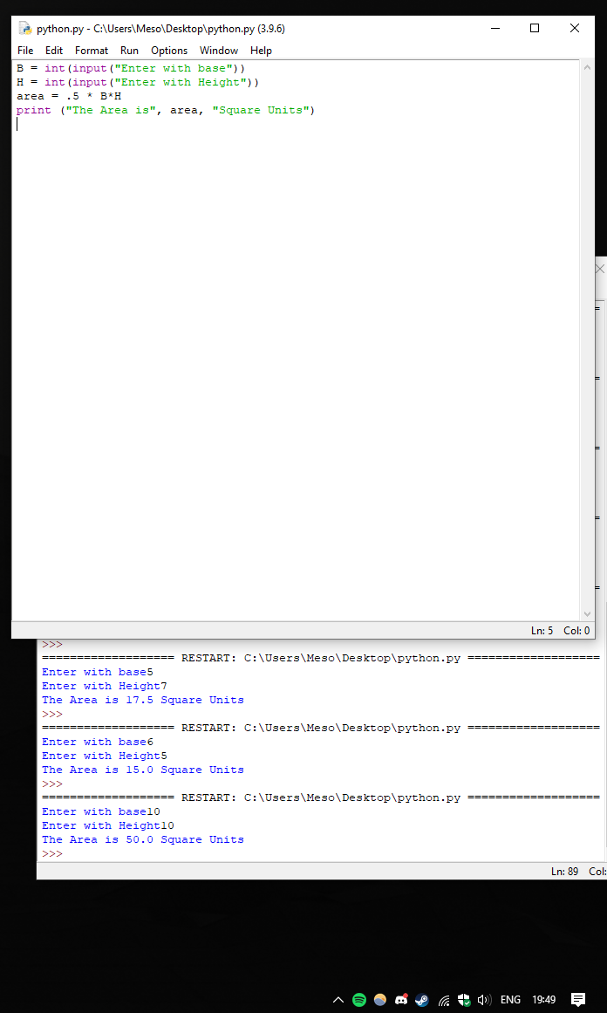
6. 